**Project 1: Draw Capital Letter K**

**Group Partners: Dhruv Rana, Christopher Fallas Aguero**

1. **Design vertices of the capital letter K.**

Vertices: K = 

1. **What is the adjacency matrix?**

Adjacency Matrix: A = 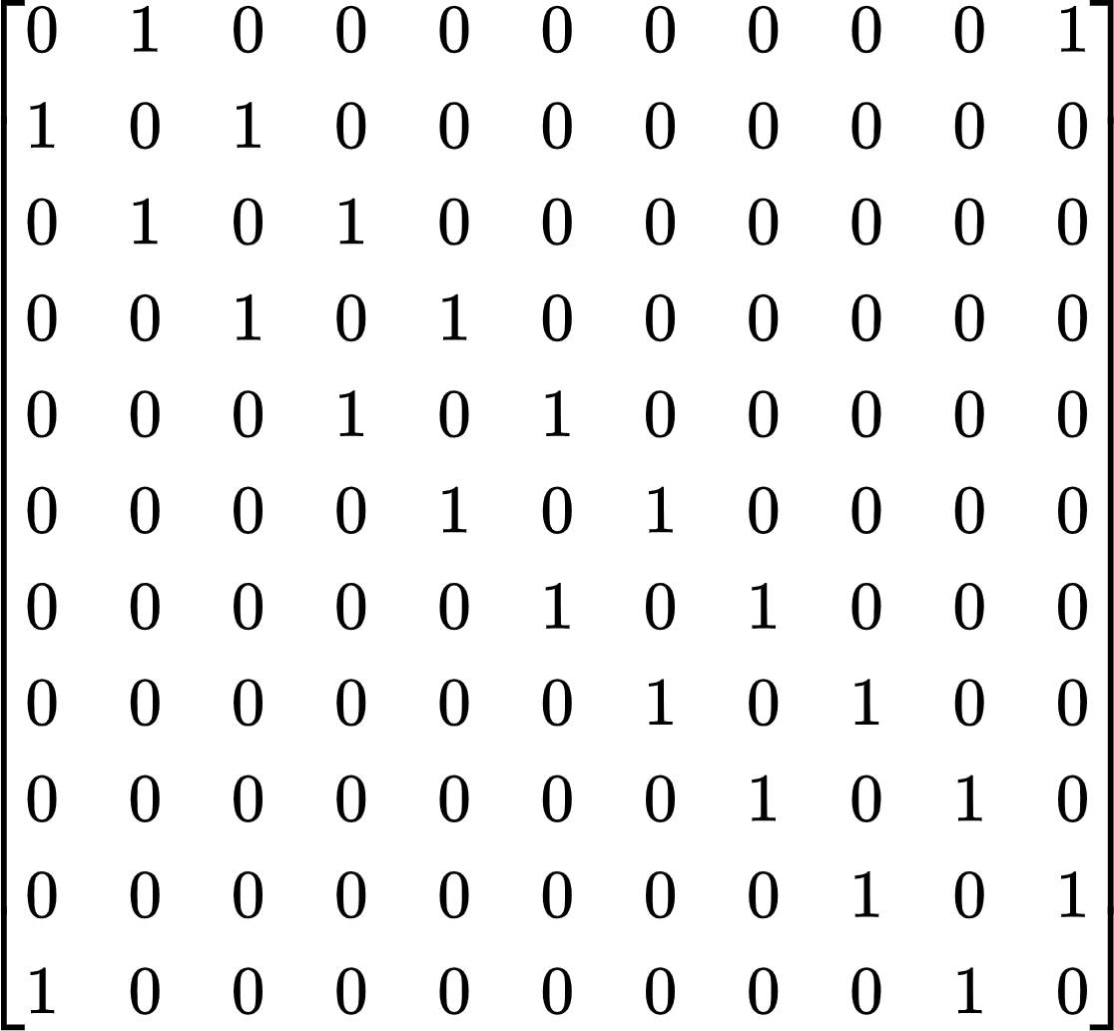

1. **Using a Python program to draw the capital Letter K.**
2. **Figure:**

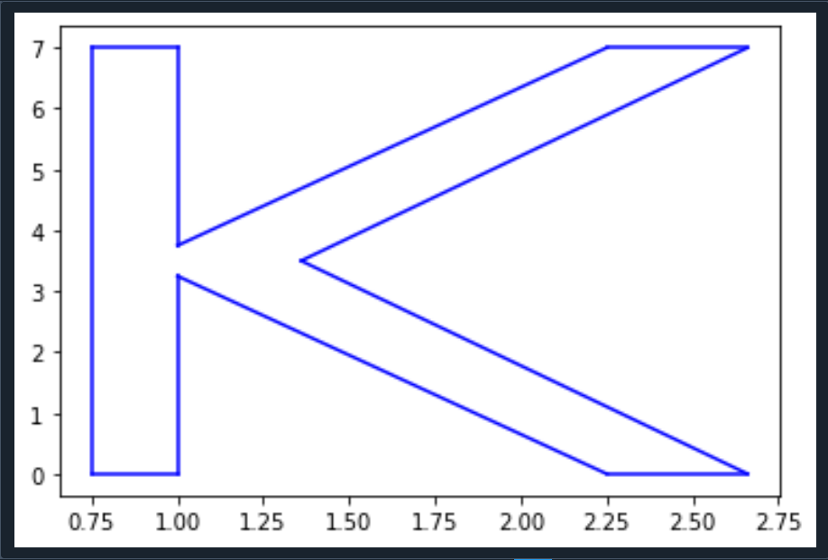

1. **Python Code to Draw K:**

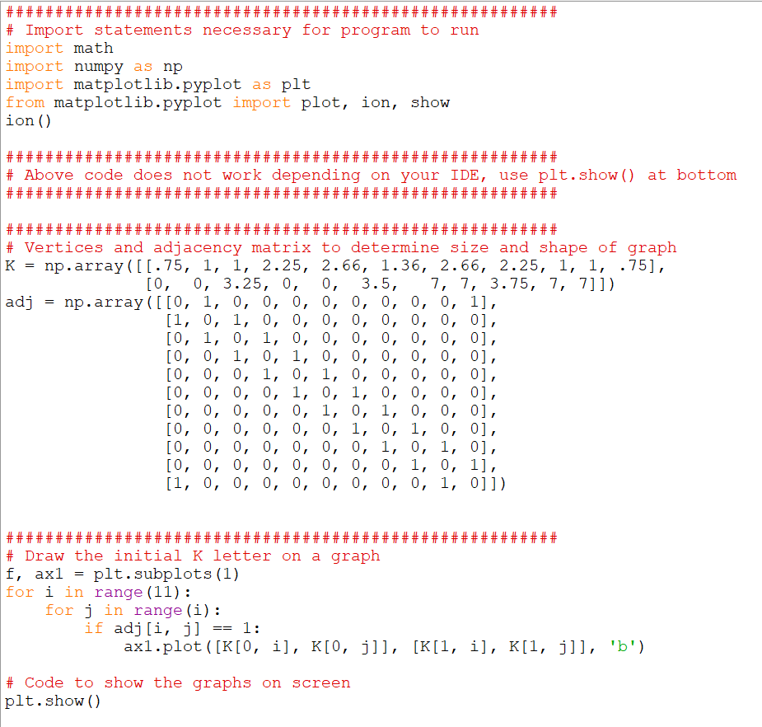

1. **Rotate the capital letter K by 45 degrees counterclockwise.**
2. **Figure:**

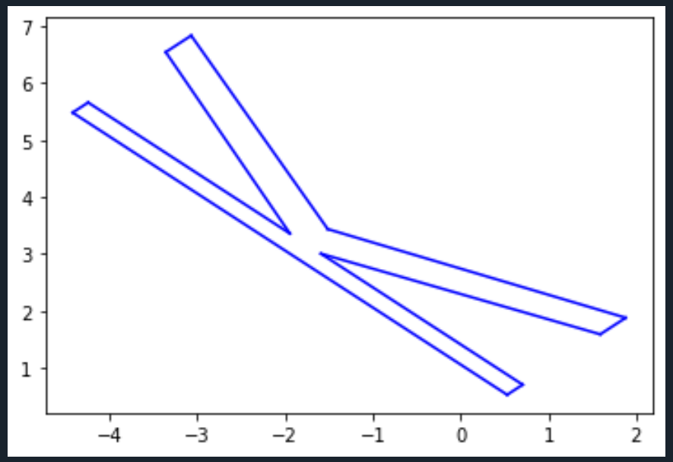

1. **Python Code to Draw K Rotated 45 Degrees Counterclockwise:**

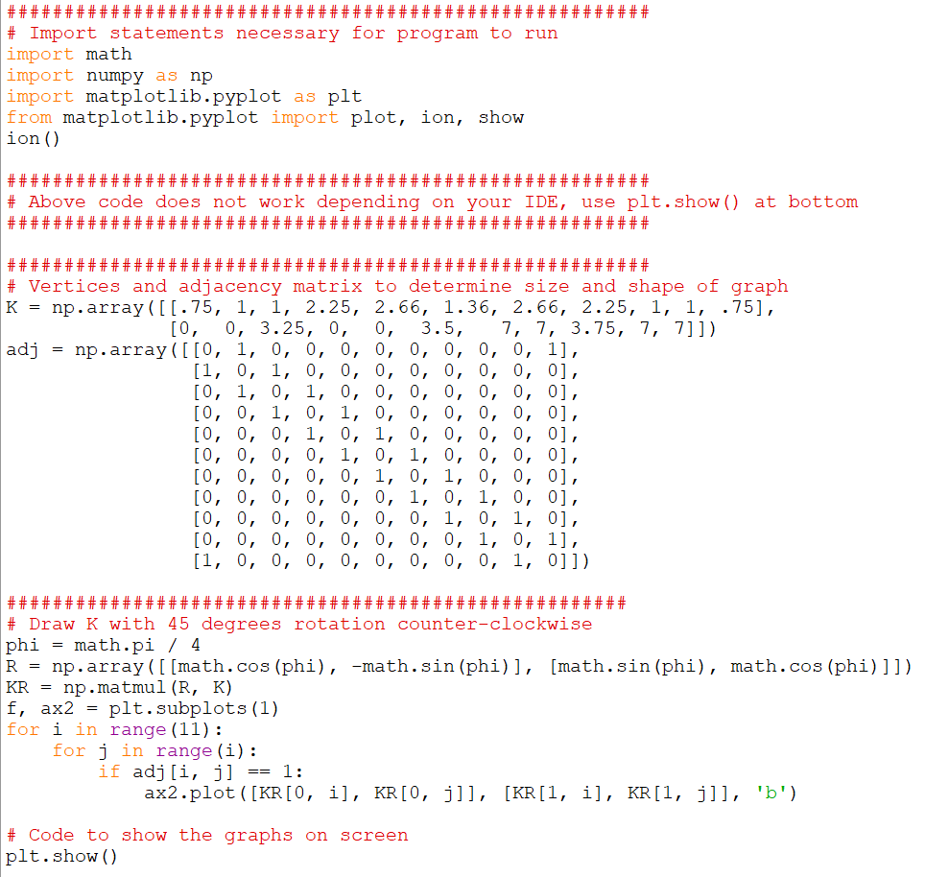

# 

# **Draw the backwards K.**

1. **Figure:**

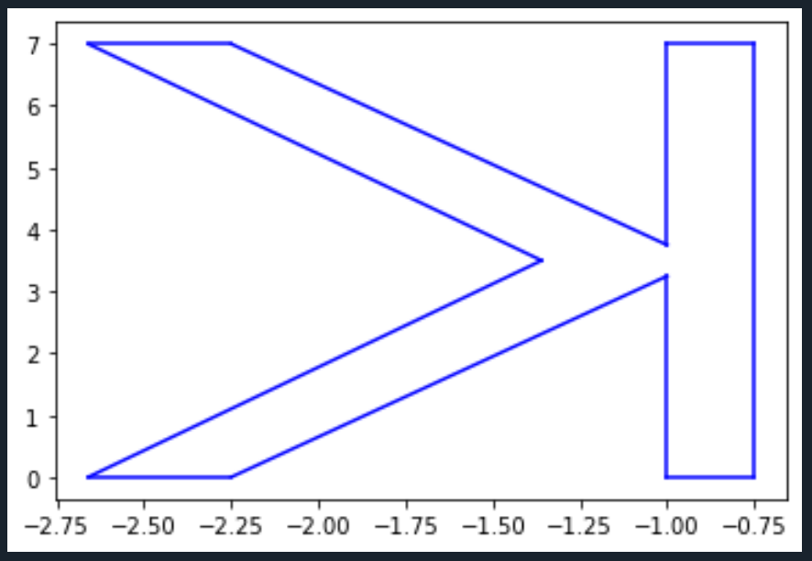

# **Python Code to Draw the backwards K:**

